**20001266 – P.I.B. Pathirana – 2020/CS/126**

1) & 2)

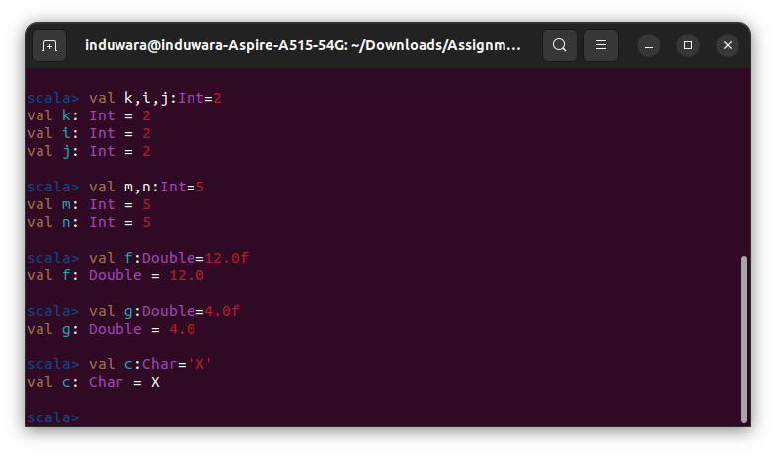

3.

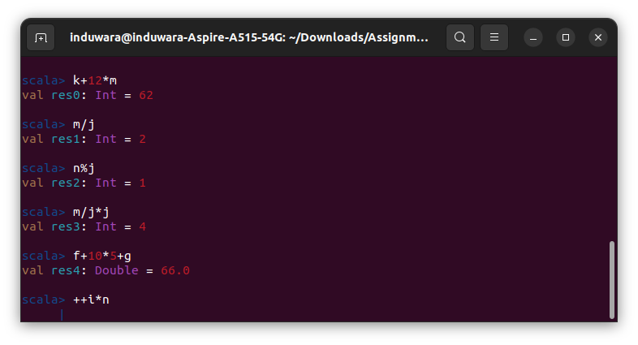

f) Scala does not support ‘++’ and ‘--’ operators. ++i*n expression is not valid.

Compare the Java and Scala programming languages.

|  |  |
| --- | --- |
| **Scala** | **Java** |
| Scala is a Object Oriented and Functional Programming. | Java is only an Object Oriented Programming. |
| Supports operator overloading. | Does not support operator overloading. |
| Scala variables are by default immutable form. | Java variables are by default mutable type. |
| Does not contain static keyword | Contains static keyword. |

* Use the following declaration and initialization to convert them to acceptable Scala statements.

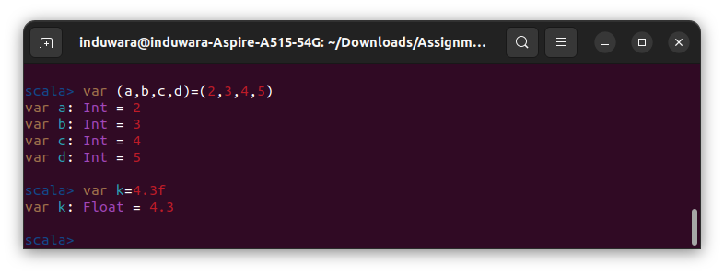

and evaluate the following expressions.

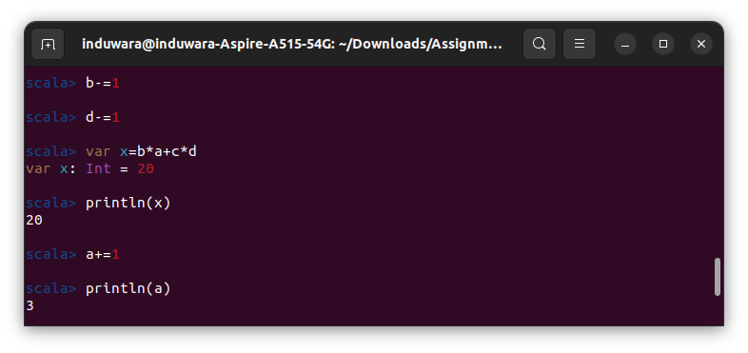

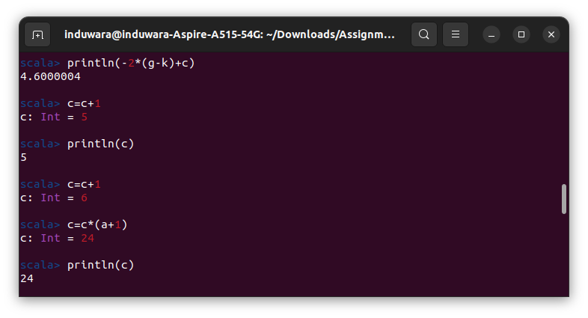

4.Write Scala functions to solve the following problems.

1. Company XYZ & Co. pays all its employees Rs.250 per normal working hour and Rs. 85 per OT hour. A typical employee works 40 (normal) and 30(OT) hours per week has to pay 12% tax. Develop a functional program that determines the take home salary of an employee from the number of working hours and OT hours given.

b. Imagine the owner of a movie theater who has complete freedom in setting ticket prices. The more he charges, the fewer the people who can afford tickets. In a recent experiment the owner determined a precise relationship between the price of a ticket and average attendance. At a price of Rs 15.00 per ticket, 120 people attend a performance. Decreasing the price by 5 Rupees increases attendance by 20 and increasing the price by 5 Rupees decreases attendance by 20. Unfortunately, the increased attendance also comes at an increased cost. Every performance costs the owner Rs.500. Each attendee costs another 3 Rupees. The owner would like to know the exact relationship between profit and ticket price so that he can determine the price at which he can make the highest profit. Implement a functional program to find out the best ticket price.